**simge, sembol, logo, ticari marka, amblem içeren bir resim

Açıklama otomatik olarak oluşturuldu**

**IE437 TECHNOLOGY MANAGEMENT**

**PROJECT REPORT**

|  |  |
| --- | --- |
| **Students Name** | Sıla Patak  Barış Köse  Özkan Perçin  Elif Güleken |
| **Project Name** | Technology Management in Packaging Factories: A Comparative Analysis of Three Plants |
| **Supervisor** | Assoc. Prof. Dr. Pınar K. Çiftçi |
| **Due date** | 27 December 2024 |

**ABSTRACT**

In today's world, institutions' ability to compete and sustain their lives depends on their ability to use and manage technology effectively. Institutions' ability to use technology effectively and efficiently brings about superiority in many aspects. Technology management, which has emerged as an academic discipline in recent years, focuses on processes that can significantly contribute to institutions' ability to manage within the framework of certain goals. As technology develops, institutions' ability to manage technology has an increasing importance in terms of the success of organizations.

Technology is increasingly taking its place in every area of ​​our lives. The rapid change experienced in technology directs businesses to reconsider their competitive conditions. Businesses' investment in technology infrastructure, both hardware and software, provides the opportunity for rapid growth. In shaping the strategic activity level of institutions; It is important that individuals working in technology management are taken into account and that it can be sustained cumulatively. As a result of institutions' effective use of technology with individuals working within their organization, production leads to more efficient results. Therefore, it is very important for institutions to adapt to technological advances by effectively designing technology management, and to be able to use and manage time in an innovative way.

In this study, we will try to reveal the effects of the concept of technology management in different companies. In order to reveal the purpose of this study and to create its content, three different companies were visited by focusing on the concept of technology and technology. In this way, the structural characteristics of the concepts of technology and technology management and their effects on the company were determined in detail.

**ACKNOWLEDGEMENTS**

We would like to thank Lidersan Packaging team, Lidersan R&D department manager İlker TÜRKMEN, Sunpet Packaging team, Sunpet Packaging Deputy General Manager Murat ÖZER, Kimpack Packaging team, Kimpack Packaging R&D department manager Cansu İÇEN, who contributed to the realization of this project.

**INTRODUCTION**

It is the management of activities and processes aimed at making innovations different from the existing ones in products, technologies and processes with the use of technology, which is defined as the totality of information, tools, procedures and methods used while creating (producing) something. Technology can be defined as the transformation of information obtained as a result of theoretical and practical studies into machines, devices and methods applicable for production and social processes. In daily life, technology is generally perceived as a physical tool (an electronic device such as a telephone or computer, etc.). When viewed from this perspective, it is seen that technology actually has two basic elements: tool (hardware) and information (software). The main value-creating aspect of technology is the information part. Technology represents a dynamic process. In this respect, technology also changes and develops over time depending on the changing needs and access opportunities for information.

Technology management, which is considered a multidimensional discipline in terms of social sciences and engineering sciences, can be defined as the process of planning, organizing, coordinating, implementing and controlling technological competencies (infrastructure, opportunities and capabilities) in order for an organization to determine its goals and achieve these goals.

There are many methods, strategies and tools used to make technological competencies suitable for the goals and objectives of an organization. These strategies and tools change according to the effects of the environmental elements (competition, technological infrastructure, etc.) in which the organizations are located. In addition, technology management includes activities, applications and processes such as technological planning, technological forecasting, R&D and technology transfer.

Technology Management is the combined use of basic sciences, engineering and management disciplines to plan, develop/provide and acquire technological capabilities required to shape and achieve the strategic goals of a business.

There are two different approaches to technology management. The first approach is a micro approach, which includes planning, coordinating and directing technology on a company basis, while the other is more macro, which examines all activities related to technological forecasting, technological planning, determination, implementation and control of science and technology policy throughout the country. In the micro approach, that is, technology management, which is addressed on a company basis, the main goal is to carry out management activities by planning, organizing and coordinating the technical possibilities and human resources in the most optimum way in order to maximize the company's profit and production. In the macro approach, TM addresses the issues of science and technology planning, policy determination and the execution of activities related to technological investments and technological infrastructure in accordance with the country's socio-economic development goals. The scope of technology management includes: Technological Forecasting, Technological Planning, Technological Risk Analysis, R&D Management, Management of Technological Innovations, Technological Competition Strategies, Technology Transfer, Technology Selection, Commercialization of Technology, Management of Engineers and Scientists, Technology and Organizational Changes. Technological forecasting and technological planning are very important in technology management. Because technological forecasting and technological planning help to use existing resources more efficiently both at the enterprise level and on a country basis.

The purpose of this research is to reveal the impact of technology management in three different packaging companies in Gaziantep. For this reason, the information obtained as a result of observation and interview was analyzed in detail and compiled into a report. In order for the above-mentioned research to achieve its purpose and to shed light on the research topic, various questions about technology management were asked to the relevant managers and answers were sought for the questions within the scope of the project.

**INTERVIEWS ON TECHNOLOGY MANAGEMENT**

**1. Lidersan Packaging**

Lidersan Packaging started its operations under the roof of Altunkaya Group in 2015 with its facilities built on a closed area of ​​25,000 m². In flexible packaging as of 2017;

– Personal Care Products

– Hygiene Components

– Household Cleaning Products

– Dry Foods, Snacks, Pasta, Ready Soup and Spice Packaging

– Beverage, Powdered Beverage, Coffee and Tea Packaging

– Bakery Products, Frozen Food

– Pet Food Packaging, Cat Litter Packaging

– Special Lamination Films

– Doypack, Quadro, Flat Bottom Bag, Reinforced Bag, Bread and Chicken Bags

**1****.1) What processes do you implement in your organization to keep up with the pace of technological change?**

As Lidersan within Altunkaya, we generally participate in machinery, raw material and innovation, patent, fair, symposium conferences worldwide in order to keep up with the pace of technological changes. We also make presentations at these conferences, symposiums or congresses. While making presentations, we also listen to the presentations of institutions and organizations participating in this platform, examine them, and communicate. At the same time, this means that we also make a competitor analysis or market analysis. We communicate with our machine inspectors. We hold meetings at certain periods, make updates. We think about where the sector is heading. We do both written and verbal research related to the sector. We frequently examine science and technology magazines and packaging magazines. We also participate in domestic and international packaging fairs. Currently, there is one in America. We have a stand there, so we both introduce our products and analyze what developments are taking place in the packaging sector there.

**1.2) How do you implement technological innovations on your employees? How does the orientation process work?**

This is the final part of the job. Because we can not integrate every technological development into ourselves. We adapt the technological developments that are suitable for us in the sector we want to exist in. First, we do a feasibility study. If our machines will be updated, we do it, if not, after meeting with our machine inspectors and customers who address the sector, we provide the necessary training to our own personnel during the process after this investment is made. For example, we have made a new investment and even will have a new one. We send the operators who will work on the machine, namely the employees at the foreman level, to training both domestically and abroad. We do not start work without preparing the infrastructure**.**

**1.3) What kind of innovations have you encountered in the packaging industry lately?**

Now, since we are already the R&D center in the packaging sector, we have to follow these technological developments closely, both in raw materials and machinery. We follow them. How do we follow them? As I have just explained, we are constantly increasing in written and verbal fairs on these platforms. In addition, we now have our own resource projects that we manage. We have TÜBİTAK projects as an R&D center.

In order for it to become a project, an innovation is a solution to a problem. Something has to happen. We have to come up with something. One of the innovations we have made recently is that Turkey did not have that machine, for example. We brought a nine-layer extruder tensioning extruder machine with a tensioning unit. First, we made the extruder unit that I have just explained, we went to Germany and received training, we conducted trials. Then we received the machine and installed it. We started trial studies here. We are currently producing as a commercialized product. We are working with Akif Bey. We developed a device that uses a different device in bags to eliminate problems that may arise from the bag.

**1.4) Do you use Artificial Intelligence or Digital Transformation AI technologies?**

Now, there were a few topics we discussed with Eren Özceylan on the artificial intelligence side. We are a facility that also manufactures plates before printing. We also adjust the designs and graphics for printing.

In other words, there is also pre-press preparation in our company. At this point, we introduced the product group we wanted with artificial intelligence to Eren Özceylan.

We even have some visual data. Then, we explained in which sector, which region these products will be sold, and what service they will provide. In the following process, we did a study on artificial intelligence. However, since we have our own graphic design team, we are currently conducting these processes with our own graphic design team and our own programs. But there will be a different project regarding artificial intelligence in the future. Or there will be a different improvement. We are always open. In addition, we use error-debugging methods such as image processing in both printing and shooting processes.

**1.5)** **How do you plan to integrate processes such as artificial intelligence and digital transformation in the future?**

We already have a software program that we are currently in transition to within our company. The management has agreed. We are in the transition phase to a software program called IFS. We will probably start using it towards the summer of next year. Our company has also received the latest version of IFS. Such software programs are already compatible and open to these processes. We also have our own software programs. We have approximately 15 software developers in our facility in the IT department. The programs that these software developers have prepared are already compatible with such robotics and artificial intelligence as databases.

**1.6) As a department manager, what are your expectations from technology?**

Some things are difficult to obtain and analyze, especially the formulation sections that Mr. İlker mentioned or the structures similar to the raw materials coming from suppliers. In such processes, it is necessary to have know-how, experience, and past knowledge. Mr. İlker can write which formulation most of the plastics he touches have. For example, when he touches the material to a robot, since he does not have the necessary knowledge, he will not be able to make any comments about the product. As we know, robots only understand 0 and 1. They do whatever you code and program. Since they do not have senses such as smell, taste, touch, it is very difficult to do these. I think some things are related to human intelligence. In other words, while I expect a lot from technology, I also think some things are limited. For example, we use the addressing method in our storage systems, but forklift drivers have to do this. Maybe in the future, we will make this system completely automation-oriented, but this also depends on the return and cost of our investment. I personally think it is not worth it in the packaging sector.

**1.7) What kind of a culture do you create to encourage technological innovation in your company?**

First of all, as a company culture, we try to continue our working life in a dynamic way that is constantly open to innovation from the lowest unit to the highest unit. As managers, we actively develop ourselves in the sector by participating in both domestic and international congresses and symposiums in every spare time we have. We aim to create a work culture that is constantly renewing itself, aware of current trends and open to development by providing an effective and efficient flow of information between our departments in our company.

**1.8) How does cybersecurity fit into your technology strategy? What are the biggest risks you face in this area?**

We have 27001 information security system related to cyber security. In fact, we applied again last week for the renewal of our document. We have two backups related to the infrastructure for the security of the information system, both of which are used for the security of our information system. We have a staff related to information processing, and they can integrate the software we want into the system. We have two backup rooms. For example, the system has closed my computers for use outside the company, and passwords are changed once a month. Because all the information related to formulations, trials and products are in this computer. The precautions we take regarding cyber security are also technologically like this.

**1.9) How do you measure the return on technology investments?**

First, we determine our goal and make plans to achieve this goal. Then, we calculate and analyze the initial costs of the investment. In addition, we measure our current performance by selecting appropriate KPIs in order to make a comparison for the situation before and after the investment. We calculate the estimated gain we expect from the investment. In the following processes, that is, after the investment is made, we make the necessary observations, measure our performance again and perform cost analysis. In this way, we can easily compare the current situation with the situation before the investment. In the areas where we see deficiencies and need improvement, we eliminate the deficiencies by applying the continuous improvement strategy, which we call KAIZEN, and effectively ensure continuous development and improvement.

**1.10) Do you expect a radical change in the long term in this sector you are in?**

Of course we expect change, after all technology and methods are constantly evolving and changing. For example, the green agreement issue is currently on the agenda. In other words, we can call it green packaging or green packaging in our sector. If I need to explain these statements a little more, there are currently official procedures regulated on this subject. These include instructions such as using materials suitable for recycling, minimizing the amount of waste, reducing the carbon footprint, the process of plastic dissolution in nature, and the use of biodegradable materials in nature. We follow the changes and adapt in the fastest and most agile way and apply them in our own facility. For example, if I were to give you an example from the world, 47% of the packaging used in France must be recyclable. Currently, there is a transition from plastic packaging to paper packaging in Turkey.

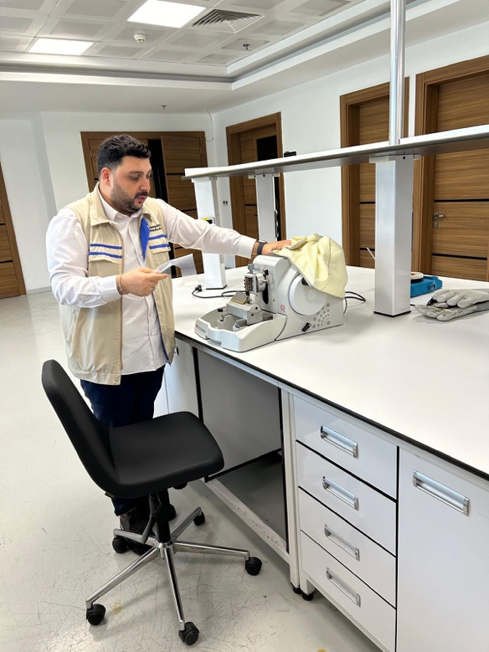

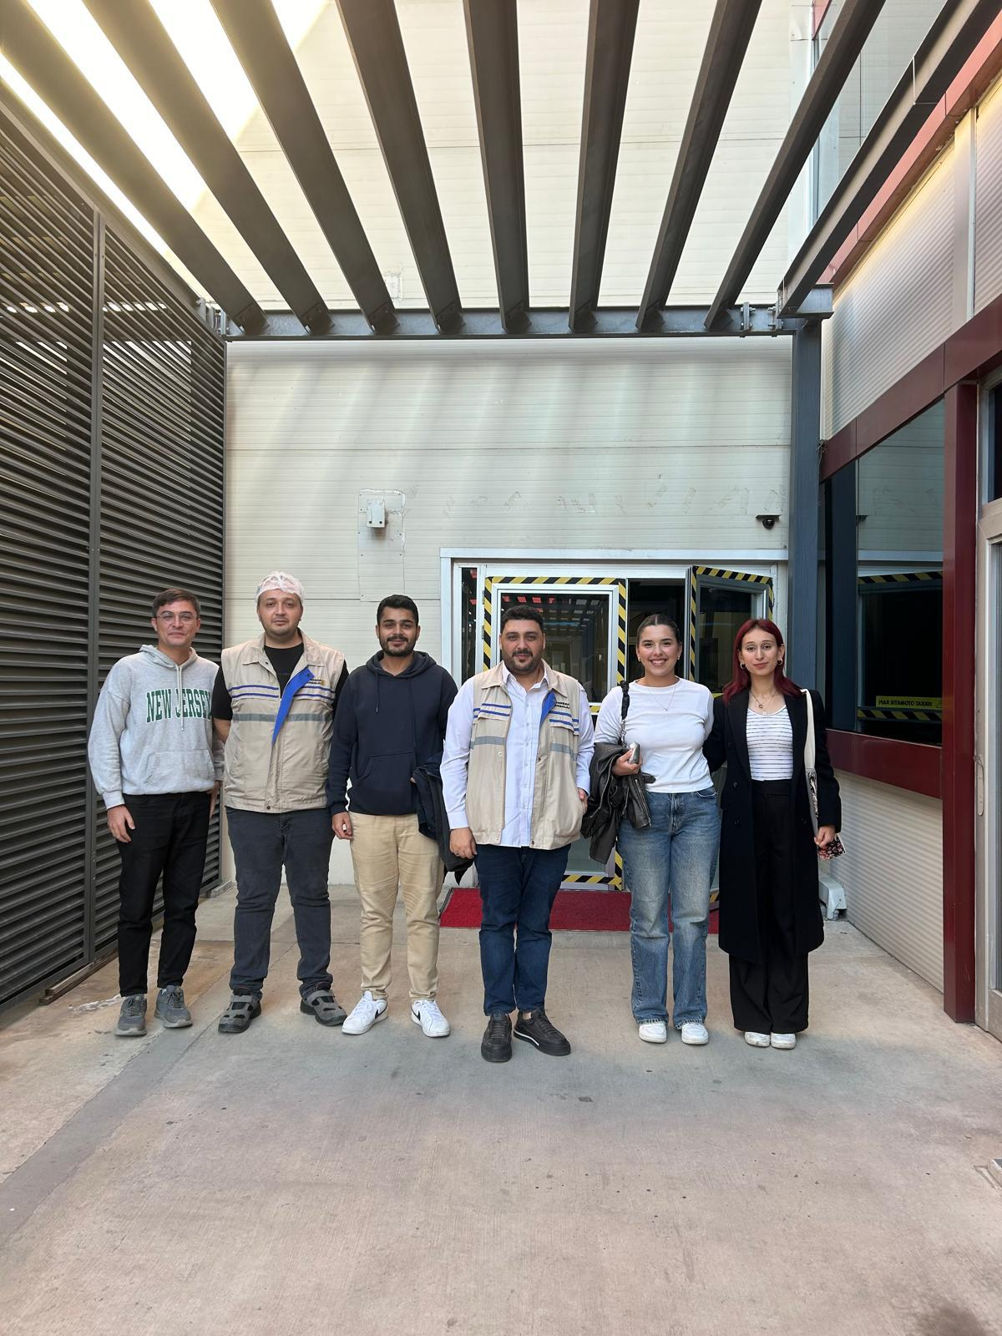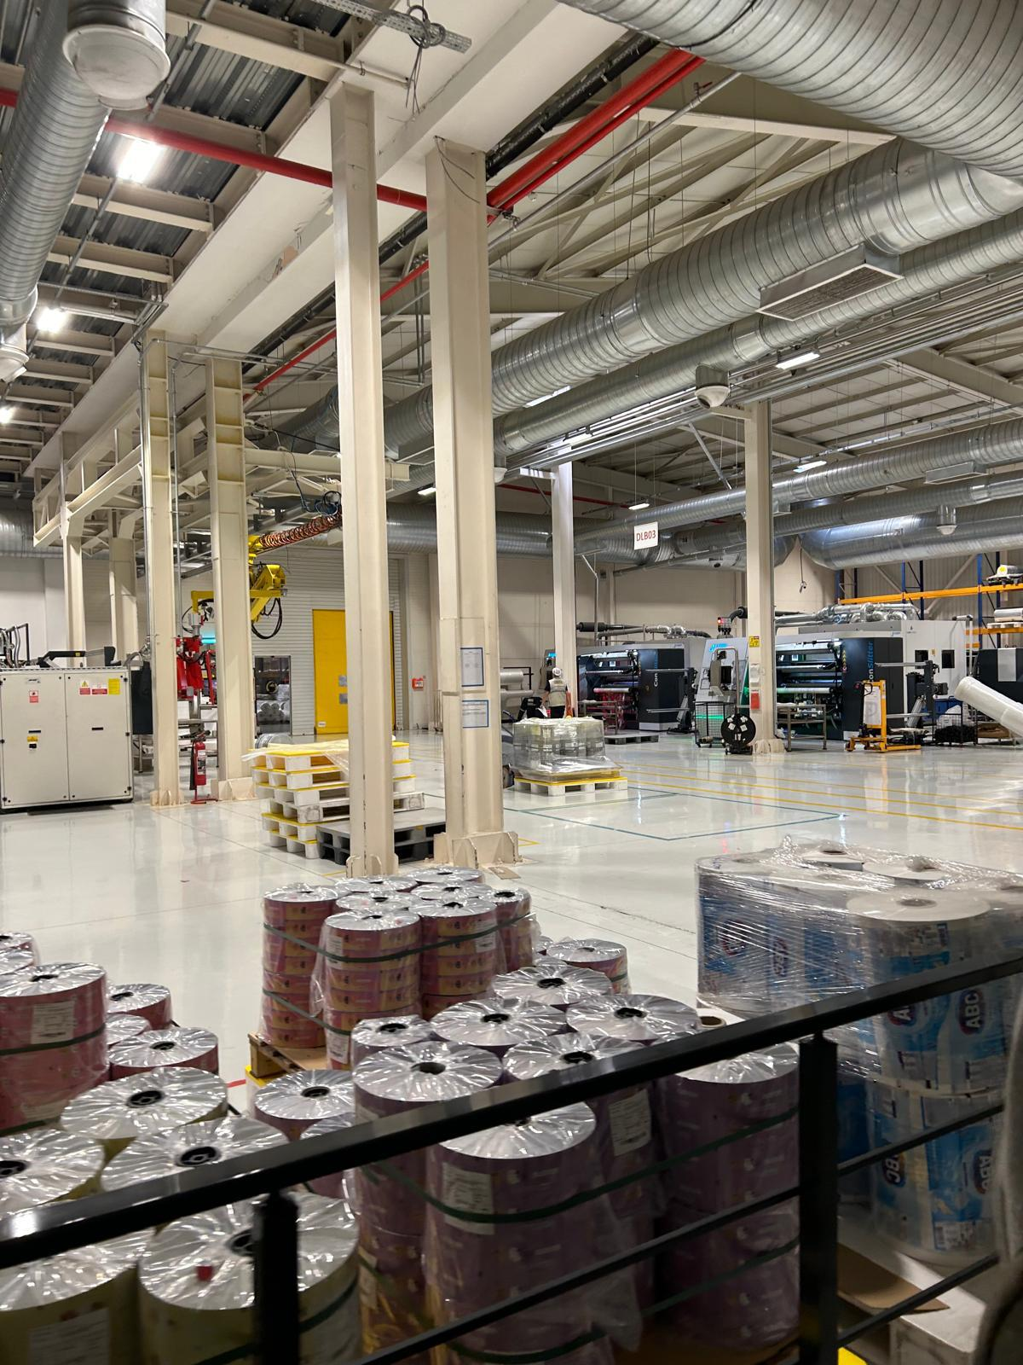

**2. Sunpet Packaging**

Started in 1998 in Gaziantep with PET preform manufacturing, their activities in the plastics sector reached an annual capacity of 72,000 tons with the facility we established in Jordan in 2010. In flexible products:

-Plastic bottles,

-Bottle’s cap

-Jars

-Various packaging solutions

-Food products

-Cosmetics

-Chemical products

**2.1 What processes do you implement in your organization to keep up with the pace of technological change?**

To start with, we participate in machine expo. We do research in the sector, especially in Germany, to find out which country is in what position and take action accordingly. By working with the best companies in the world, we aim to ensure that the products we produce are of high quality. We stay in close contact with Germany and Spain about the processes and thus we provide a continuous flow of information in terms of machinery. We have to follow the technology closely so that the cost decreases and the production continues efficiently**.**

**2.2 How do you implement technological innovations on your employees? How does the orientation process work?**

We apply the orientation process to our employees with the trainings provided by our R&D department on product and technical issues. There are also training units in our HR department and various theoretical trainings are given to our employees.

**2.3 What kind of innovations have you encountered in the packaging industry lately?**

The concept of sustainability is very popular at the moment, and everyone is now responsible for producing biodegradable, recyclable products. This increases the cost of the product significantly, so the important thing is not to be able to produce but to be able to sell that product. It is important to meet the demand with the right pricing.

**2.4 Do you use Artificial Intelligence or Digital Transformation AI technologies?**

I don't think there is a company in the sector that actively uses artificial intelligence, but we have plans for automation. At the moment, we do not have a budget that can cover the cost of software such as artificial intelligence and digital transformation, but we get help like everyone else on necessary issues.

**2.5** **How do you plan to integrate processes such as artificial intelligence and digital transformation in the future?**

In fact, it is difficult to do in our sector because there is a human factor and the system is actually based on control with software. When we produce a product, we define this product, design the product with its dimensions and teach it to the machine. In other words, it can be said that we both do and don't do it. As I said, it is a bit difficult in the packaging sector, it could be in the automotive sector. It is difficult because we do not make standard mass production. It can be successful in sectors such as pharmaceuticals, textiles, etc. The packaging sector is a human doomed sector.

**2.6 As a department manager, what are your expectations from technology?**

First of all, being able to access technology cheaply, unfortunately, access to technology is very expensive in our country. It is cheap to access technology abroad, but people have no sense of curiosity. In Turkey, the situation is the opposite. I wish the state would give us support and incentives to teach us these technologies. Having data in foreign languages is also a very big problem, because not every manager has a foreign language. If you are a curious, research-loving manager, you can do these things. Young people need to be more willing.

**2.7 What kind of a culture do you create to encourage technological innovation in your company?**

We have an IT department but it is not fully developed. We think we can increase it by coloring it with HR and social media management, but these increase the cost. We actively follow new technologies on Linkedin, Twitter and Instagram.

**2.8 How does cybersecurity fit into your technology strategy? What are the biggest risks you face in this area?**

Companies normally have a 27001 audit. It is usually found in most companies. There are also documents such as information security and food safety. Currently, our company does not have it, but we are thinking of getting it in the future. We currently have know-how information. Of course, we do not want these to fall into the hands of other people, so we will take the necessary actions.

**2.9 How do you measure the return on technology investments?**

Technological investments in the packaging sector are generally aimed at increasing quality and efficiency. There is no special way to do this. We are looking at how much our company pays credi rating (penalty). We evaluate and take into account customer complaints and feedback.

**2.10 Do you expect a radical change in the long term in this sector you are in?**

Packaging seems to be the biggest growth area in the world in the next five years, but plastic packaging is a big problem. Materials that can be recycled are desired, but for example, you cannot store a coffee in paper packaging for long days. So even though no one wants it, it harms the nature. For this reason, it is difficult to predict where this recycling issue will go. Environmental issues will occupy an important place in this sector in the coming years.

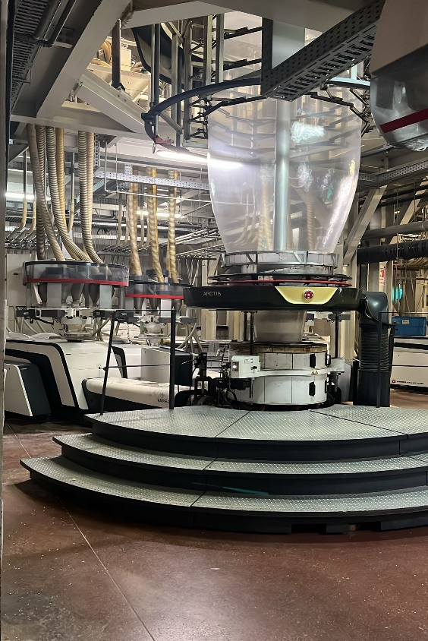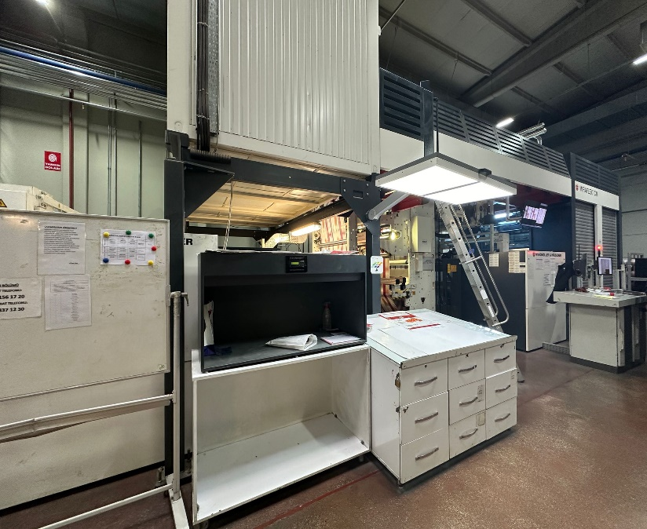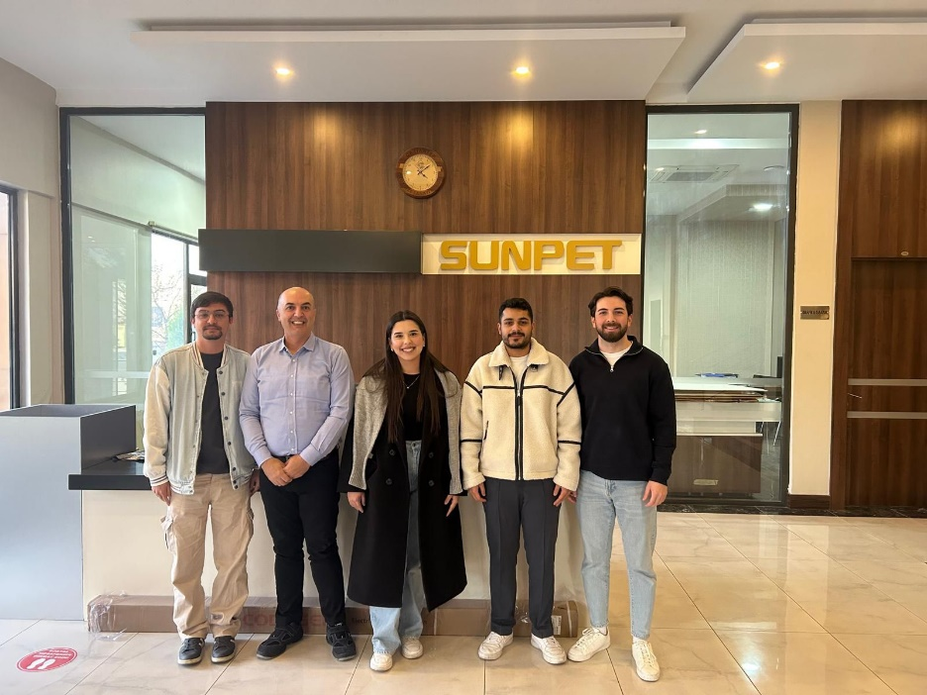

**3 Kimpack Packaging**

Kimpack has one of the largest facilities in the Middle East and Europe with an annual production capacity of 280,000 tons. With its 2000 employees, it carries out both production and service processes with a flawless approach and operates as a global brand with exports to 80 countries. It continues its operations with an innovative and responsible approach in a closed area of ​​150,000 m².

-Shrink Film

-Stretch Film

-Pallet Covers

-Heavy Duty Bags

-Greenhouse Covers and Mulch Films

-Home Textile Packaging

-Printed and Unprinted Bags and Pouches

-Compostable Bags Made of Biopolymer

**3.1** **What processes do you implement in your organization to keep up with the pace of technological change?**

We actively use artificial intelligence in the R&D department. We follow our competitors by participating in events such as symposiums and congresses. We also follow developments in the field of machinery. We try to follow the sector closely. Speaking of expos abroad, for example, we try to regularly attend the expo held in Germany every three years, thus expanding our network.

**3.2 How do you implement technological innovations on your employees? How does the orientation process work?**

We teach our work discipline and our job in detail in order to effectively include our personnel in the process. For example, we recently provided TRIZ training. In addition, we train our personnel by sending them to congresses and symposiums. Our training continues on a departmental basis, regardless of whether it is in-house or outside the institution. We try to adapt the training to everyone, regardless of their title.

**3.3 What kind of innovations have you encountered in the packaging industry lately?**

I can say sustainable technology, sustainable products and the heavy regulations it brings. What is important in the new era is the reusability of the product. The amount of garbage and waste is increasing every day. We are also trying to produce more products with less packaging by using bioproducts, in other words, we are trying to increase efficiency. Legislations and laws are being created, but it is difficult to predict what the process will bring. For example, if you had asked three or four years ago, I would have said that bio-based products were more important, but today, production based on recycling is more prominent.

**3.4 Do you use Artificial Intelligence or Digital Transformation AI technologies?**

We use it like this, and we ask it questions. Personally, I don't think artificial intelligence is 100% accurate. Artificial intelligence weakens people's thinking, reasoning, and decision-making skills. Humans are the best at taking the easy way out. We ask whether we can use our own product, product A, for product B. Some of these guiding questions are what substances we can use for raw materials, compounds, and newly designed products.

**3.5 How do you plan to integrate processes such as artificial intelligence and digital transformation in the future?**

With technological infrastructure and investments, we have new generation extrusion machines. In addition, these machines will change, we will use more automated artificial intelligence systems with modification, we will integrate them and support these processes with more investments.

**3.6 As a department manager, what are your expectations from technology?**

Lean production, but integrating lean production into our own company is a bit difficult in our sector. Since there are machines that work 24/7, it is difficult to implement and the probability of failure is high for these machines.

**3.7 What kind of a culture do you create to encourage technological innovation in your company?**

There is no fully developed culture at the moment, but we are trying to create this culture with various trainings. Culture changes with new technologies, and we send our employees to various trainings and encourage them with various supports to adapt to this culture.

**3.8 How does cybersecurity fit into your technology strategy? What are the biggest risks you face in this area?**

We use SAP system for R&D, everyone has authorization limits in this system, meaning not everyone can use this system as they wish, thus authorizations are limited. We ensure confidentiality within the company with such measures. We also provide various trainings to our employees regarding information security system and information flow. Passwords are also changed at certain times.

**3.9 How do you measure the return on technology investments?**

We look at the feasibility, cost and profit of the project with the success of the products we produce. First, we prepare a prototype and send it to the customer. We adjust the product according to the feedback from the customer and reach the final point, then we regularly monitor the continuity and usability of our product in cooperation with our after-sales service department.

**3.10 Do you expect a radical change in the long term in this sector you are in?**

As I said, there may be changes in sustainability. For example, recycling, carbon footprint, green packaging, green packaging, etc. The packaging sector is already at the top right now, so there will always be new participants. In addition, the importance of this sector will increase as a result of the increasing industrialization of food. We expect continuous growth. If I were to give an example of the current trend, using recycled materials in food packaging.

iç mekan, tavan, zemin, duvar içeren bir resim

Açıklama otomatik olarak oluşturuldu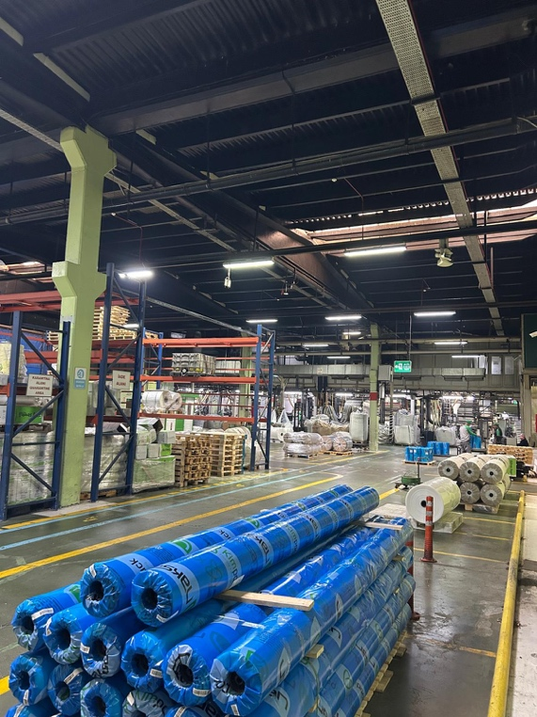

giyim, kişi, şahıs, gülümsemek, gülüş, ayakkabı içeren bir resim

Açıklama otomatik olarak oluşturuldu

Based on our factory visits, observations and interviews, we identified the areas in which all three companies were developed and lacking. As a result, we understood that concepts such as technology, technology management, following current trends, and attending training and congresses related to the relevant sector are of critical importance for companies to survive in the market in the long term and to ensure their sustainability. We also saw that technology management is an important assessment tool in showing the level of development of companies.